Read me with screenshots.

How to run this web app? (Using Windows)

1. Open BuiltSight_UI_edit.sln in Visual Studio Community. Select branch "jsx-starting-point".

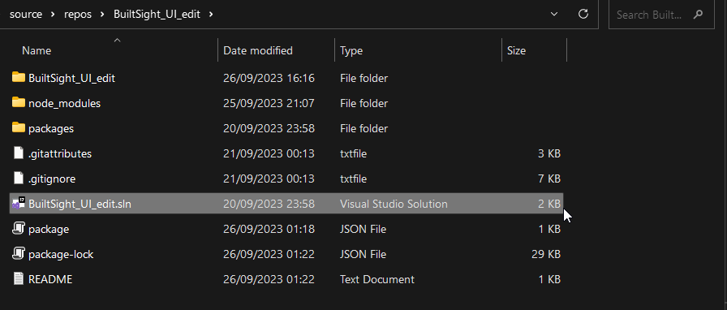

2. In the Solution Explorer, right click "BuiltSight_UI_edit" (with a green ball icon).

3. Select "Open Folder in File Explorer".

4. Locate the folder "clientapp", double click it.

5. In the file location bar, type in "cmd"

6. Type in command "npm start".

7. The web app will show up in your default browser, if not you can type in "http://localhost:3000" into your browser.

